

Computer Engineering Department
Course name: Web Technologies
Course code: 2CP08
Faculty: Prof Kirtikumar Sharma

ID: 23CP029
Name: Viral Vipulkumar Bhoi
Topic: Report of LAB - 2

LAB 2: Develop static web page of irregular tables using the HTML Tags AND Develop static web page of Registration form using HTML tags

TABLE OF CONTENT:

2.1 static web page of irregular tables. . . . . . . . . . . . . . . . . . . . . . . . . . . . . . . . . . . . . . . . . . . . 3
2.2 HTML code for creating irregular tables . . . . . . . . . . . . . . . . . . . . . . . . . . . . . . . . . . . . . . 4
2.3 OUTPUT of code . . . . . . . . . . . . . . . . . . . . . . . . . . . . . . . . . . . . . . . . . . . . . . . . . . . . . . . . . . 6
2.4 static web page of Registration form . . . . . . . . . . . . . . . . . . . . . . . . . . . . . . . . . . . . . . . . . 7
2.5 HTML code for creating registration form . . . . . . . . . . . . . . . . . . . . . . . . . . . . . . . . . . . . . 8
2.6 OUTPUT of code . . . . . . . . . . . . . . . . . . . . . . . . . . . . . . . . . . . . . . . . . . . . . . . . . . . . . . . . . . 12

2.1 static web page of irregular tables::

- <table> </table>
  - Used for creating a table.
- <tr> </tr>
  - Used to define a row in the table.
- <td> </td>
  - Used to define a data cell in the table.
- <th> </th>
  - Used to define a header cell in the table.
- colspan
  - Used to merge <td> or <th> cells into single column.
- rowspan
  - Used to merge <td> or <th> cells into single row.
- border
  - defines width of border.
- cellpadding
  - adds space between cell content and cell border.
- cellspacing
  - adds space between two cell border.
- align
  - Used to align item horizontally in cell.
- valign
  - Used to align item vertically in cell.

2.2 HTML code for creating irregular tables:

<html>
<head>
<title>
table using HTML Tags
</title>
</head>
<body>
<table border="1px" align = "center" cellpadding="20px" cellspacing="3px">
<tr>
<th colspan ="3" rowspan="2"> Today's Opinion Poll Question
</th>
<th colspan ="3"> Political Party </th>
</tr>
<tr>
<td> Democrate </td>
<td> Republican </td>
<td> independent </td>
</tr>
<tr>
<td rowspan="3" colspan="2">
"Do you favor or oppose <br>increasing the minimum <br>wage?"
</td>
<td> Favor </td>
<td align="right" valign="middle" > 70% </td>
<td align="right" valign="middle" > 35% </td>
<td align="right" valign="middle" > 55% </td>
</tr>
<tr>
<td> Oppose </td>
<td align="right" valign="middle" > 25% </td>
<td align="right" valign="middle" > 60% </td>
<td align="right" valign="middle" > 30% </td>
</tr>
<tr>
<td> Unsure </td>
<td align="right" valign="middle" > 5% </td>
<td align="right" valign="middle" > 5% </td>
<td align="right" valign="middle" > 15% </td>
</tr>
</table>
</body>
</html>

2.3 CODE OUTPUT:

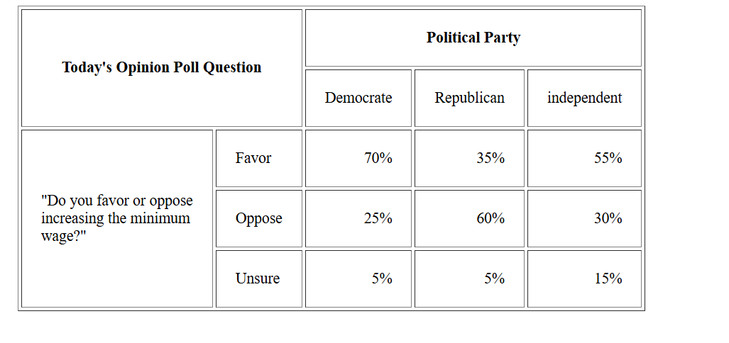

2.4 static web page of Registration form::

- <form> </form>
  - Used for creating a form.
- <input> </input>
  - Used to get data.
- type:
  - text: used to insert single line text data.
  - Password: Used for entering passwords.
  - Date: Used to select a date from a calendar.
  - Number: Used to insert numeric value.
  - Email: used to insert email.
  - Hidden: not visible to user.
- required:
  - Ensures the field must be filled out before submission.
- <select> </select>
  - Used to create dropdown menu in form.
- <option> </option>
  - Used to create option of dropdown.
- <input type="radio">
  - Used to select one option from a group.
  - name: Groups related radio buttons.
  - checked: Sets a default selection.
- <input type="checkbox">
  - Used to select one or multiple options.
  - checked: Sets a default selection.
  - name: Groups related checkboxes.
- <textarea> </textarea>:
  - Used to get multiple line input.
  - rows: Specifies the number of visible rows.
  - cols: Specifies the width in columns.
- <input type="submit">
  - Creates a button to submit the form.
- name:
  - Specifies the name of the input field.
- value:
  - Defines the default value of the input field.
- placeholder:
  - Provides a hint or description inside the input field.

2.5 HTML code for creating registration form:

<html>
<head>
<title>
table using HTML Tags
</title>
</head>
<body>
<center>
<h1>Birla Vishwakarma Mahavidyalaya</h1>
<h3>An Autonomous Institution</h3>
<form>
<table width="80%" border="10px" border-color="black" bgcolor="#91ecfa">
<tr>
<th colspan="2"> <h1>SEM 4 Registration Form</h1></th>
</tr>
<tr>
<td> Select Acedemic year : </td>
<td>
<select name="Year">
<option value ="2024-25"> 2024-25 </option>
<option value ="2023-24"> 2023-24 </option>
<option value ="2022-23"> 2022-23 </option>
<option value ="2021-22"> 2021-22 </option>
</select>
</td>
</tr>
<tr>
<td> Semester Type : </td>
<td>
<select name="type">
<option value ="odd"> odd </option>
<option value ="even"> even </option>
</select>
</td>
</tr>
<tr>
<td> Select Semester : </td>
<td>
<input type="text" name="fee" value="SEMESTER 4" readonly> </input>
</td>
</tr>
<tr>
<td> Select Date : </td>
<td>
<input type="date"></input>
</td>
</tr>
<tr>
<td> Enetr Your id : </td>
<td>
<input type="text"></input>
</td>
</tr>
<tr>
<td> Choose your password : </td>
<td>
<input type="password"></input>
</td>
</tr>
<tr>
<td> Enetr Your Name : </td>
<td>
<input type="text"></input>
</td>
</tr>
<tr>
<td> Select your gender : </td>
<td>
<input type="radio" name="gender" value="male" checked> Male </input>
<input type="radio" name="gender" value="female"> Female </input>
</td>
</tr>
<tr>
<td> Your Address : </td>
<td>
<textarea name ="address" rows="5" cols="30" placeholder="Enter your address"></textarea>
</td>
</tr>
<tr>
<td> Subjects: </td>
<td>
<input type="checkbox" name="sub" value="2CP06"> Data Structure<br> </input>
<input type="checkbox" name="sub" value="2BS01"> Differential and ordinary equation<br> </input>
<input type="checkbox" name="sub" value="2CP05"> Computer Architecture and organization<br> </input>
<input type="checkbox" name="sub" value="2CP07"> Computer Networks<br> </input>
<input type="checkbox" name="sub" value="2CP08"> Web Technologies<br> </input>
</td>
</tr>
<tr>
<td> Fees : </td>
<td>
<input type="text" name="fee" value="1050" readonly> </input>
</td>
</tr>
<tr>
<th colspan="2">
<input type="submit"></input>
</th>
</tr>
</table>
</form>
</center>
</body>
</html>

2.6 CODE OUTPUT:

